**Original**:

A truck must travel from New York to Los Angeles. As shown in Figure 5.44, several routes are available. The number associated with each arc is the number of gallons of fuel required by the truck to traverse the arc. Determine the route from New York to Los Angeles that uses the minimum amount of gas.

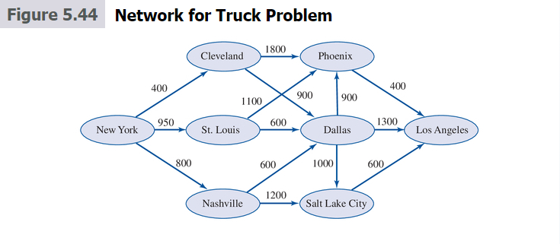

**Before Re-write**:

When I looked at the map, I found our that the route from St. Louis to Salt Lake City takes less time than the St. Louis to Dallas. Then I added one more route from St. Louis to Salt Lake City and the gallons of fuel use is 500. Also, I added a cost of travelling in different place. So we can do either optimize the total cost or optimize the gallons of fuel. Besides, we also can add profits of it later to make it become more fun.



500

**Re-Write**:

The Devil Circus is on a world tour. However, they plan to do a simple tour test in U.S. first since they don’t have much experiences about the world tour. They are traveling from New York to Los Angeles. As shown in Figure 5.44, several routes are available. The number associated with each arc is the number of gallons of fuel required by the truck to traverse the arc. There is a cost of different cities they stay (without considering any profit they can make in that city now) that shows in the excel (in thousands). They’ll collect some useful information and gain some experiences during the test tour. Since it’s a test tour, they try to use the minimum amount of gas.

Here is the model (we can also try to optimize cost, I did both in excel)

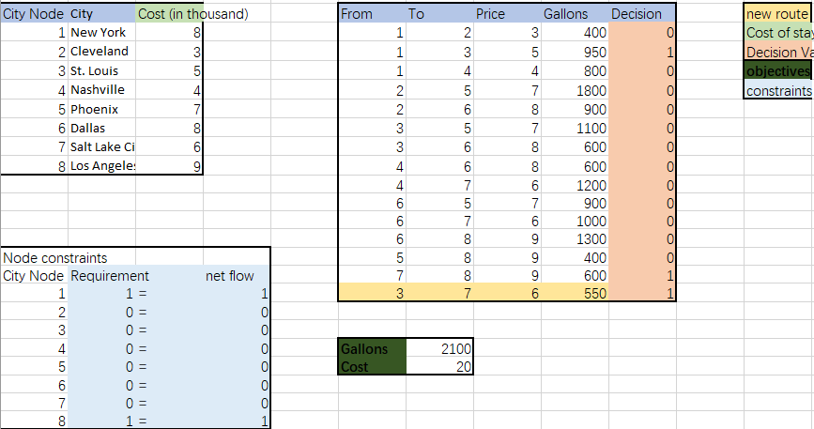

**Parameters**

i ϵ {1,2,… .8}

j ϵ {1,2,… .8}

i, j ϵ index for city node

Aij: gallons of fuel travel from city I to city j

Ci: Cost of staying in city i [use if we want to optimize cost]

Ri: net outflow requirement of the node i (show as requirement in the excel)

**Decision**:

Xij: Decision variable of whether to travel from route I to route j

**Objective**

Minimize total fuel

$\operatorname{Min}{\sum_{ij}{A_{ij}{*X}_{ij}}}$.

**Constraints**:

1. $X_{ij}$ ϵ {0,1} [Binary Constraints]

2. - = Ri, [Net outflow node meets requirement]